Name: Harsh Ghaoghave PRN : 25070521179
7.1.1] Inverted Star Pattern
Algorithm
Step 1: Start
Step 2: Read an integer value n from the user.
Step 3: Initialize a loop from i = n down to 1 (decreasing by 1 each time).
Step 4: For each value of i, print i number of * (stars).
Step 5: Repeat Step 4 until the loop ends (when i becomes 0).
Step 6: Stop
Flowchart
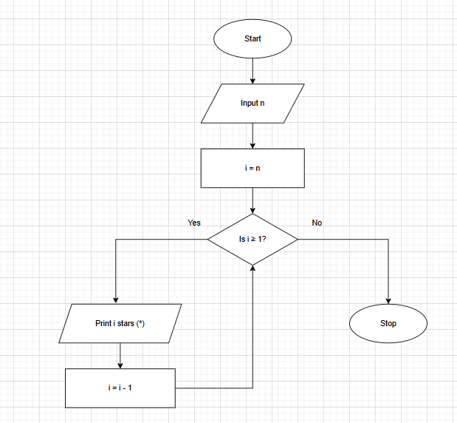

PYTHON CODE
n = int(input())
for i in range(n,0,-1):
print("*"*i)
EXCECUTION
